PHY 108 .
Assignment10
Ampere’s Law:
Ch-29:50
We have discussed the problem below in class.
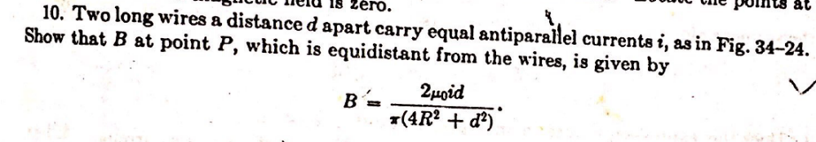
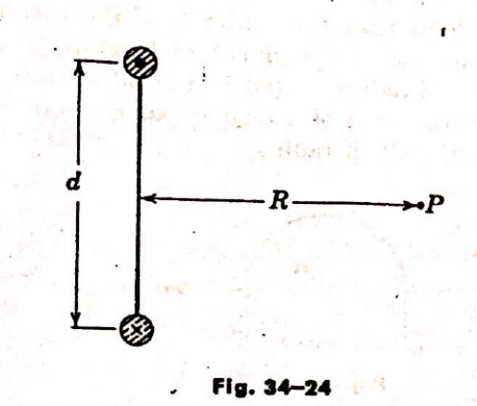
Q. Four long, parallel conductors carry equal currents of I= 5.00 A. Figure is an end view of the conductors. The direction of the current is into the page at points A and B (indicated by the crosses) and out of the page at C and D (indicated by the dots). Calculate the magnitude and direction of the magnetic field at point P, located at the center of the square with an edge length of 0.200 m
